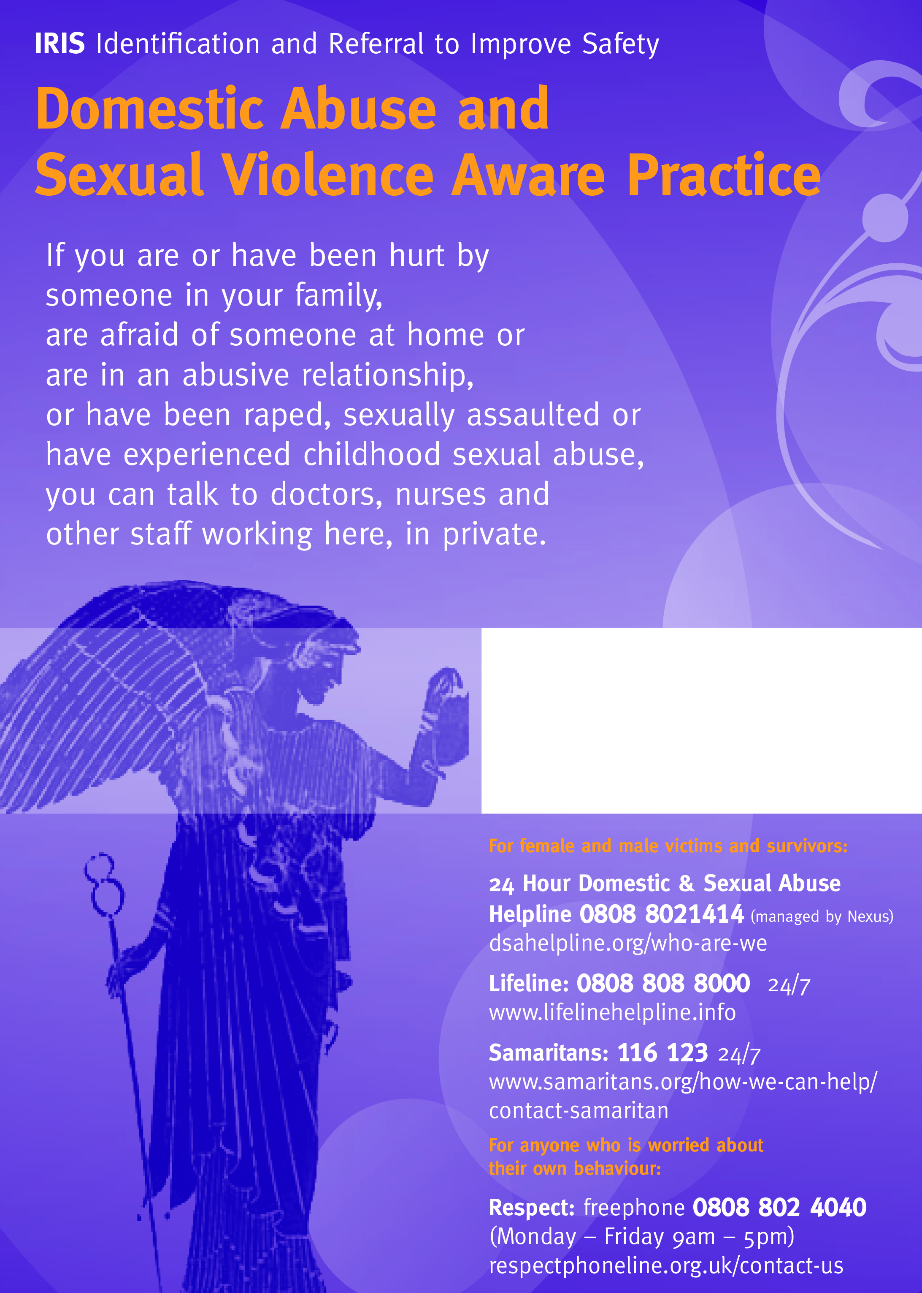

**Speak to your GP or a member of   
the GP practice staff or call;**

**The IRIS worker on**

**07739 085483**